DECLARE

n1 INT;

BEGIN

n1:=45;

IF n1>10 THEN

DBMS_OUTPUT.PUT_LINE('The Value is Greater Than 10');

END IF;

END;

/

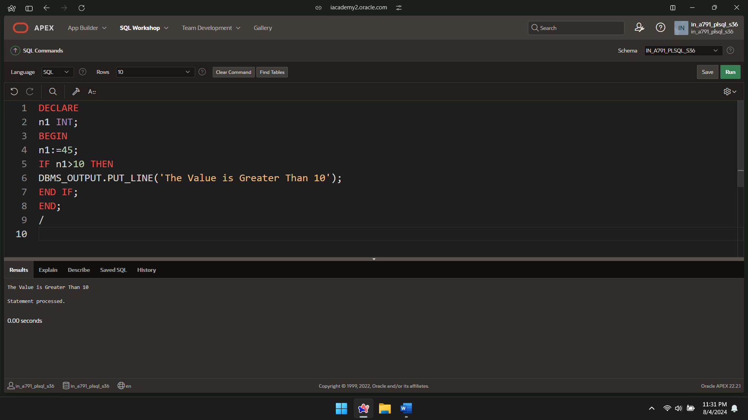

DECLARE

n1 INT;

BEGIN

n1:=7;

IF n1>10 THEN

DBMS_OUTPUT.PUT_LINE('The Value is Greater Than 10');

ELSE

DBMS_OUTPUT.PUT_LINE('The Value is Lesser Than 10');

END IF;

END;

/

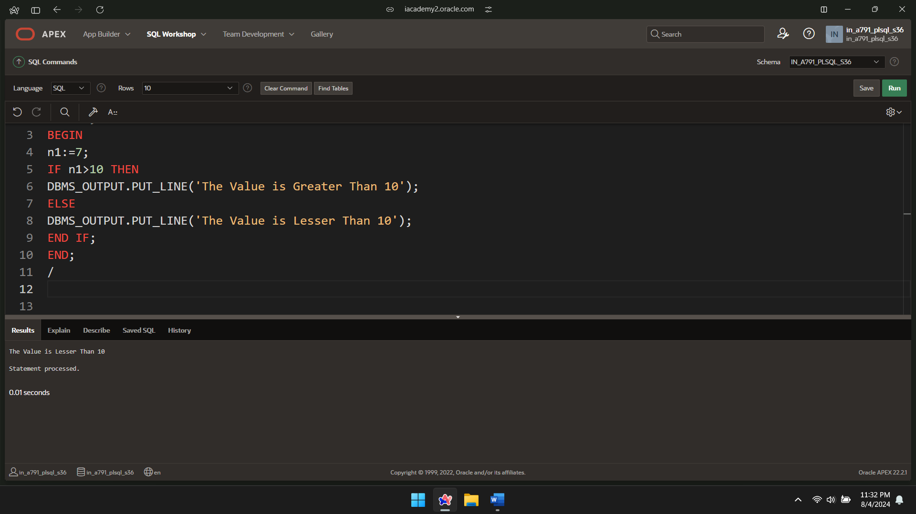

DECLARE

age NUMBER := 25;

status VARCHAR2(20);

BEGIN

IF age<18 THEN

status:='Minor';

ELSE

IF age<60 THEN

status:='Adult';

ELSE

status:='Senior';

END IF;

END IF;

DBMS_OUTPUT.PUT_LINE('Status: '||status);

END;

/

